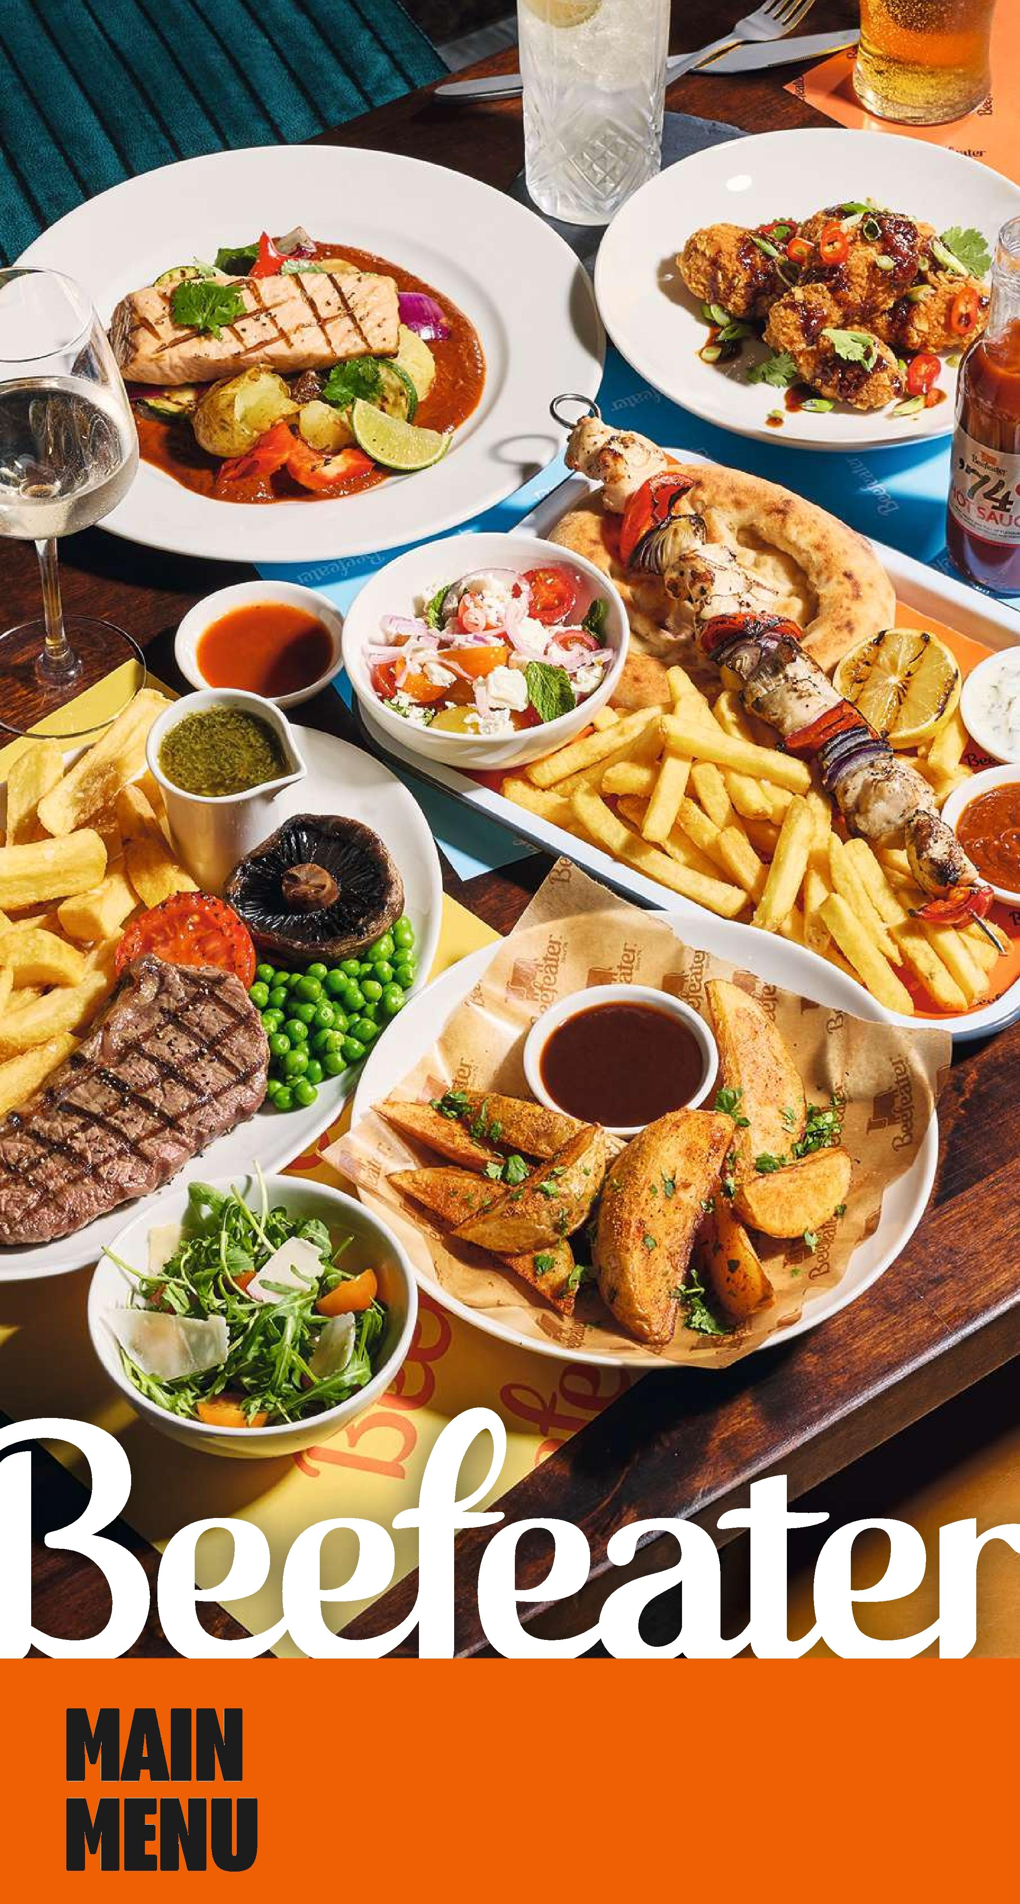

**WELCOME**

**Here at Beefeater, you'll find freshly grilled food just as it should be. It's what we do best and what we've been doing since 1974. Using the finest ingredients and our expert knowledge, we create delicious food to enjoy with family and friends, whatever the occasion.**

**So, take a moment to savour the quality of our 100% British and Irish steaks, or our beer-battered fish and chips, or simply enjoy one of your favourites. Now's the time to sit back, relax and enjoy your meal. Everything tastes better from the grill!**

**Our irresistible '74 dishes showcase the very best of Beefeater. Specially created by our grill masters using the best quality ingredients, unique blends of herbs and spices, and their passion, knowledge and skill for aLL things from the grill.**

I

I   
I I

**■ ■ ■ ■ ■ ■ ■ ■**

■ ■ ■ ■ ■ ■ ■ ■ ■ ■

**'74 Bacon Relish** (41kcaL)

**'74 Honey & Mustard (V)** (139kcaL) **I**

**'74 Mango, Peach** I

**& Habanero *ii* (Ve)** (35kcaL)I

**'74 Spicy Mayo *i* (Ve)** (87kcaL)I

I **TRY OUR '74 SAUCES**

**0.99 each**

I **'74 BBO* (Ve)** (36kcaL)

I **'74 HOT *iii (Ve)*** ( 13kcaL)

I **'74 Burger (Ve)** (1O2kcaL)

I **'74 Smokehouse**

I **Tomato (Ve)** (57kcaL)

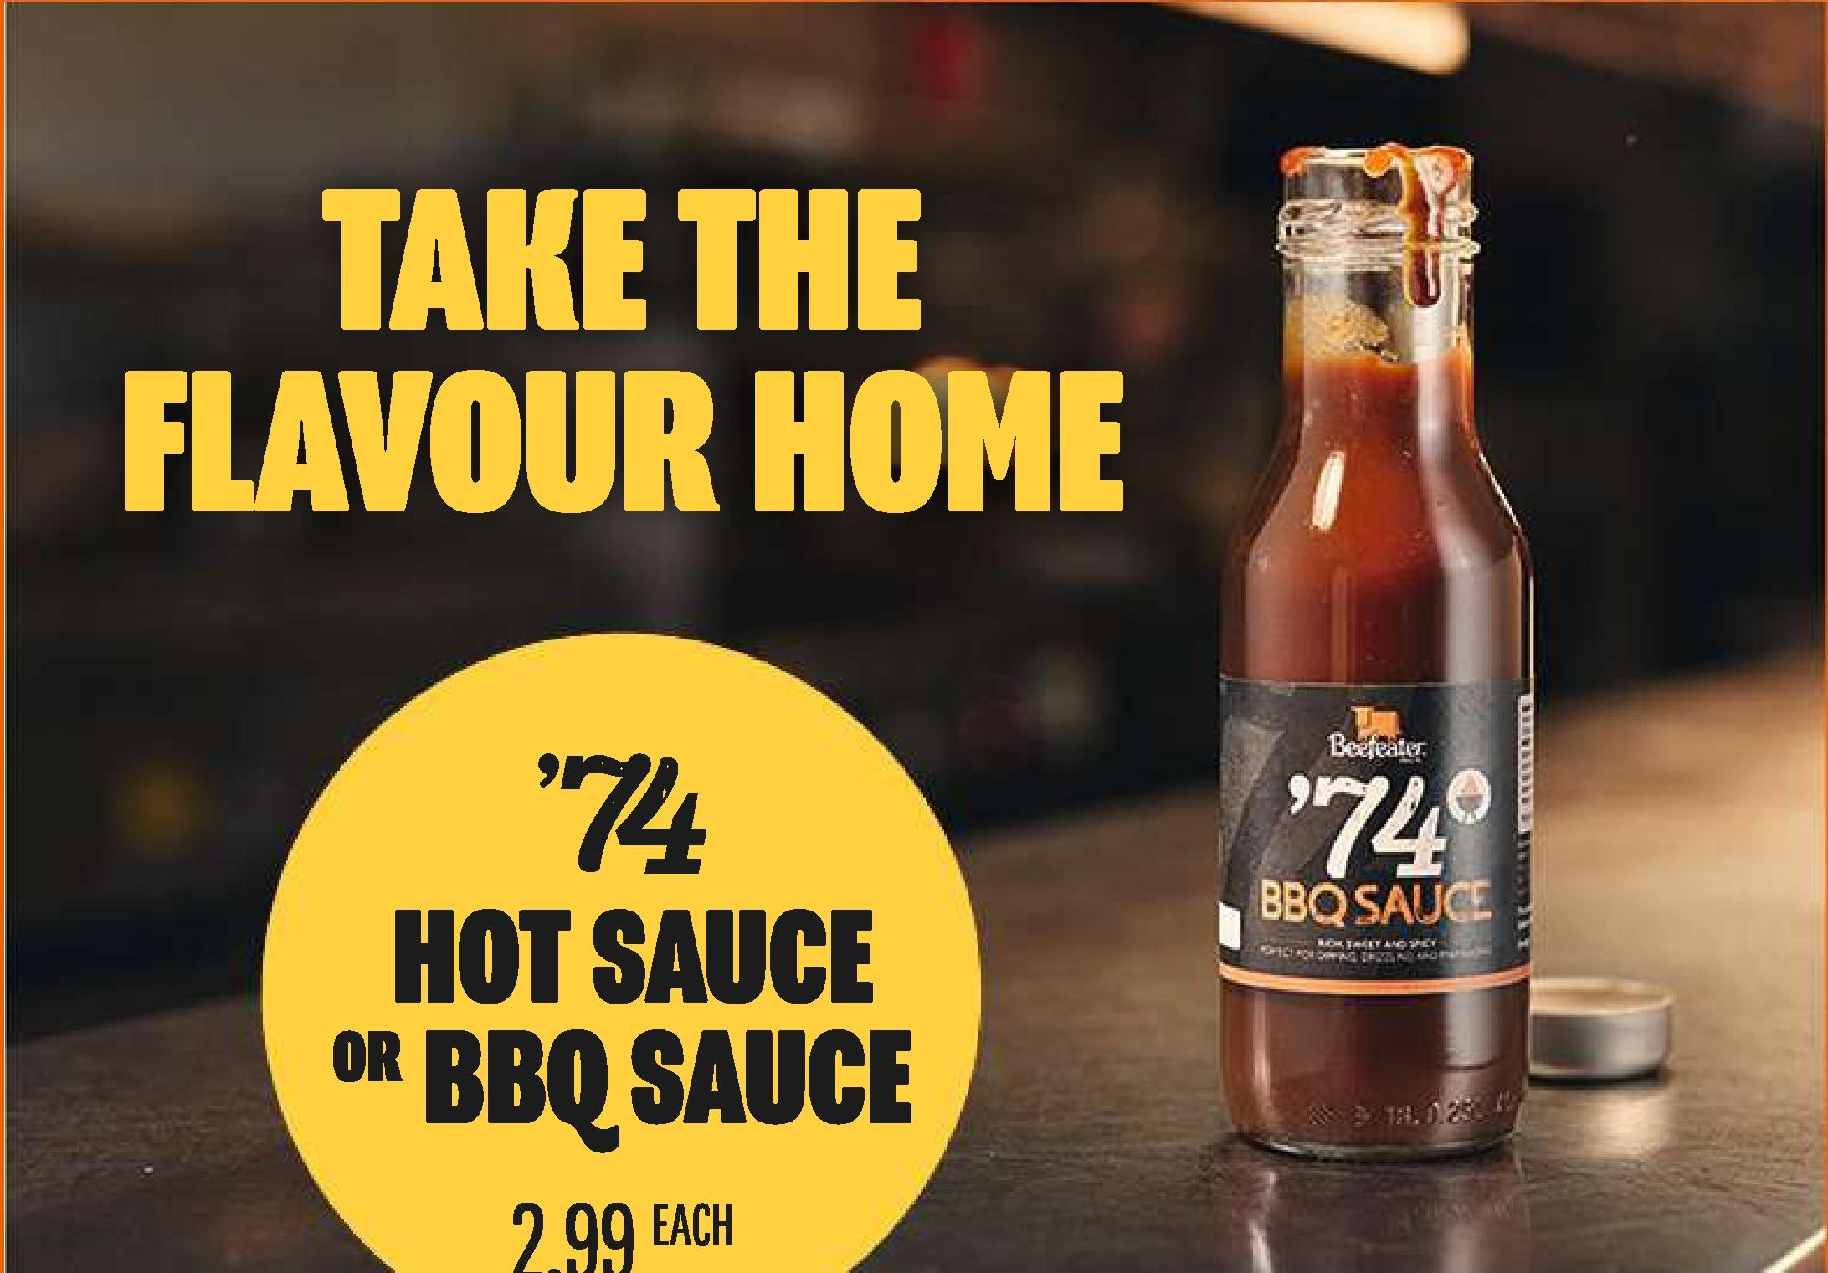

|  |  |  |
| --- | --- | --- |
| **■ ■ ■ ■ ■ ■ ■** | ■ ■ ■ ■ ■ ■ ■ ■ ■ ■ ■ |  |

|  |  |
| --- | --- |
| **STARTERS i ki;‘11** | **4 FOR £17.99**  **3 FOR £14.99** |
|  |

II

I

I

I

I

I

I

I

I

II

I

I

|  |  |  |
| --- | --- | --- |
| **■ ■ ■** | ■ ■ ■ ■ |  |

**'74 Double-Crunch**



**'74 Double-Crunch Chicken Wings & Pizzetes**

**Chicken Wings**

Our ’74 loaded crunchy tortilla-coated wings seasoned with our signature blend of spices choose from:

**Korean-inspired 6.99**

drizzled with soy, chilli & ginger

sauce (638kcal)

**Mango, Peach & 6.99**

**Habanero**

|  |  |  |
| --- | --- | --- |
| **■ ■ ■** | ■ ■ ■ ■ |  |

with grilled pineapple salsa(678kcal) **Garlic Breaded Mushrooms 5.99**

Served with your choice of '74 sauce (383kcal without sauce)

**'74 Double-Crunch 6.99**

**King Prawns\*\***

Served with your choice of '74 sauce (221kcal without sauce)

**Halloumi Fries 6.79**

Served with your choice of '74 sauce (423kcal without sauce)

**Crispy Calamari\*** **6.79**

Served with your choice of '74 sauce (365kcal without sauce)

**Chicken Goujons 6.99**

Served with your choice of '74 sauce (370 kcal without sauce)

**'74 BBQ Seasoned 5.79**

**Potato Wedges (Ve)**

Served with your choice of '74 sauce (397kcal without sauce)

**Loaded Nachos (V) 6.49**

Cheddar cheese sauce, guacamole, tomato salsa and reduced-fat soured cream. (530kcal)

**Want to make it vegan? Just ask! (Ve)** (528kcal)

|  |
| --- |
| **PIZZETTE**  **Freshly baked and Loaded with your choice of:** |

**Garlic, Cheddar 5.99**

**Cheese & Mozzarella (V)**

(671kcal)

**Salsa Verde, Fresh 5.99**

**Tomatoes & Parmesan**

(495kcal)

**Harissa Red Pepper 5.99**

**& Feta (V) (**452kcal)

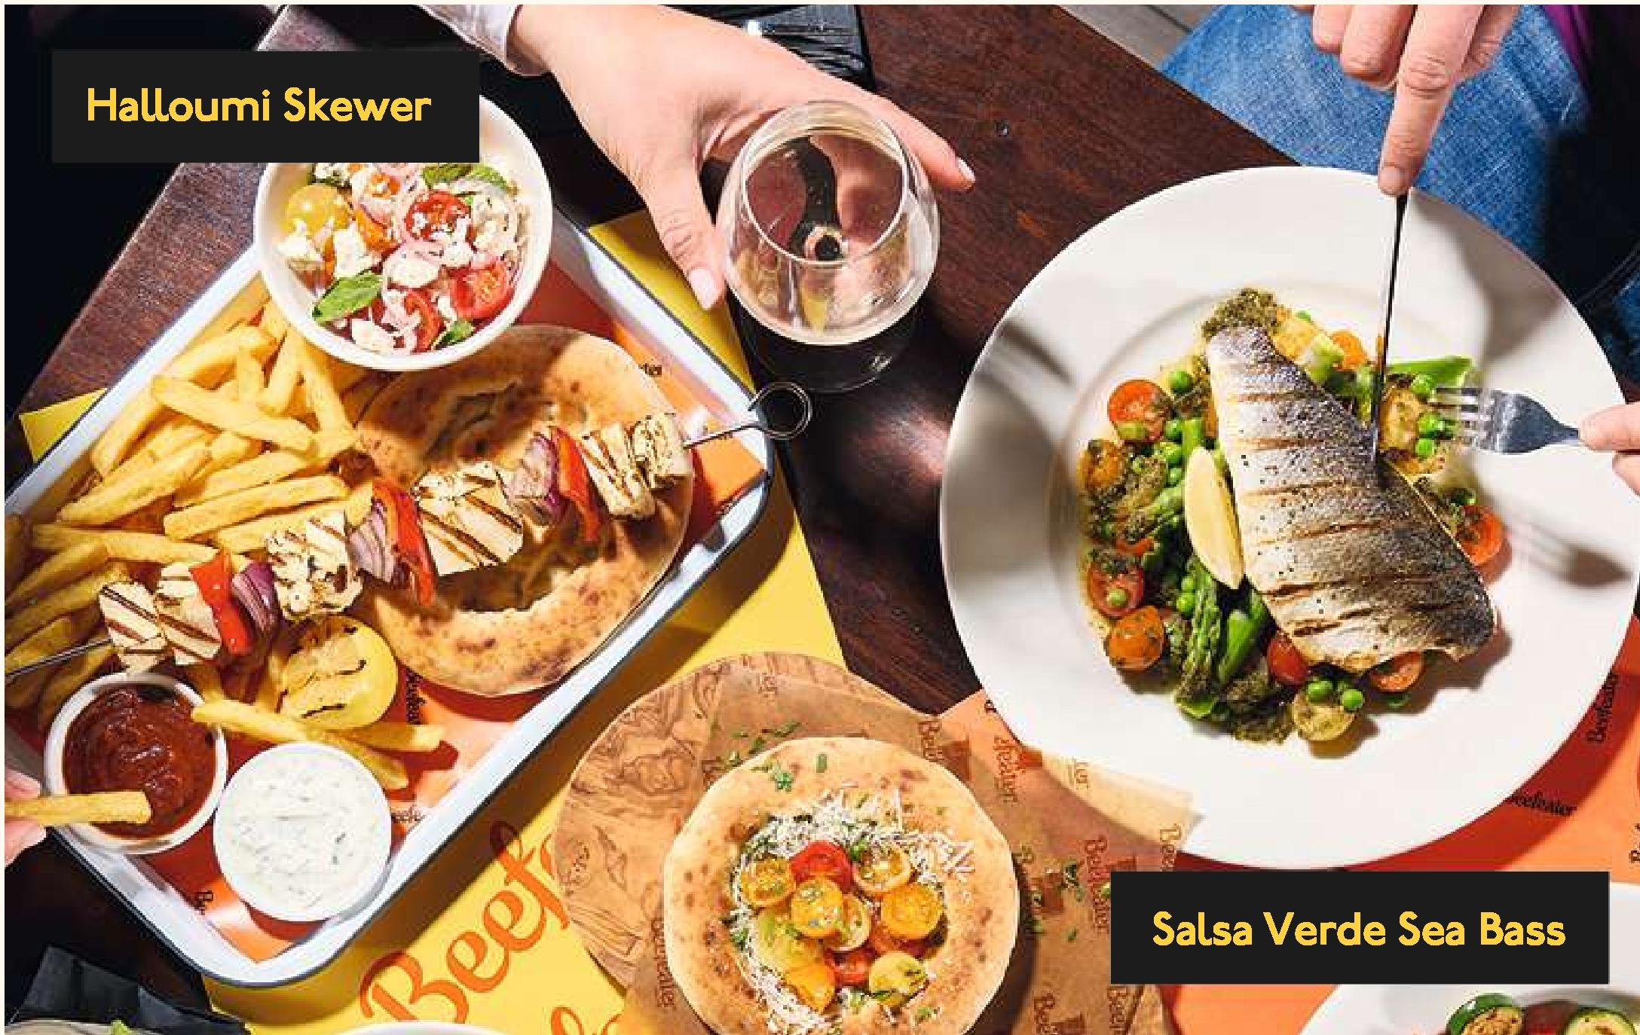

**CHARGRILLS**

**House Mixed Grill 20.99**

4oz* rump steak, half a chicken breast, gammon, two pork sausages. With a grilled tomato, two fried eggs, beer-battered onion rings5, triple-cooked chips and garden peas (1,502kcal)

**Upgrade to 8oz* Rump Steak +4.99** (1,662kcal)   
**Upgrade to 8oz* Sirloin Steak +5.99** (1,662kcal)

**Harissa & Red Pepper Salmon** 18.49**

Served with crushed roasted potatoes and grilled veg (692kcal)

**7oz* Gammon Steak 14.79**

With a fried egg, pineapple, triple-cooked chips and peas (899kcal)

**Double up your Gammon Steak +3.49** (+327kcal)   
**Add our '74 Honey & Mustard Glaze (V) +0.99** (+I39kcal)

**Salsa Verde Sea Base** 17.49**

Served with crushed roasted potatoes, grilled asparagus, mixed fresh tomatoes and peas (723kcal)

**SKEWERS**

**Chargrilled Chicken Skewer 16.49**

With a Greek salad, harissa red pepper sauce **&** tzatziki (I,2I7kcal)

**Halloumi Skewer (V) 15.99**

With a Greek salad, harissa red pepper sauce **&** tzatziki (1,359kcal)

**ALL our skewers are served with a freshly baked pizzette and skin-on chips**

**Chimichurri Vegetable 14.99**

**Skewer§ (Ve)**

With a chopped salad and chimichurri sauce (992kcal)

**SALADS**

**8oz* Sirloin Chimichurri Steak 18.49**

**Sala&**

Served with crushed roasted potatoes, rocket, Parmesan and mixed fresh tomatoes (762kcal)

**Mediterranean Salad Bowl (Ve) 14.49**

With mixed fresh tomatoes, pickled red onion, citrus grains, houmous, grilled veg and rocket (48I kcal)

**Add Pizzette (Ve) +499** (+370kcal) **Add Chicken Breast +3.49** (+I55kcal)

**Adults need around 2,000kcal a day**

**House Salad (V) 14.49**

Cos lettuce, red peppers, cucumber, mixed fresh tomatoes, sweetcorn and garlic herb croutons (I32kcal).

Finished with your choice of dressing: our '74 Honey & Mustard (V) (+I86kcal), reduced-calorie Caesar (V) (+IIOkcal)

or French dressing (Ve) (+87kcal)

**Topped with your choice of:**

**Grilled Chicken Breast** (+I55kcal)

**GARDEN GOURMET® Sensational- Chicken Style Fillet (Ve)** (+170kcal)

**Grilled Halloumi (V)** (+352kcal)

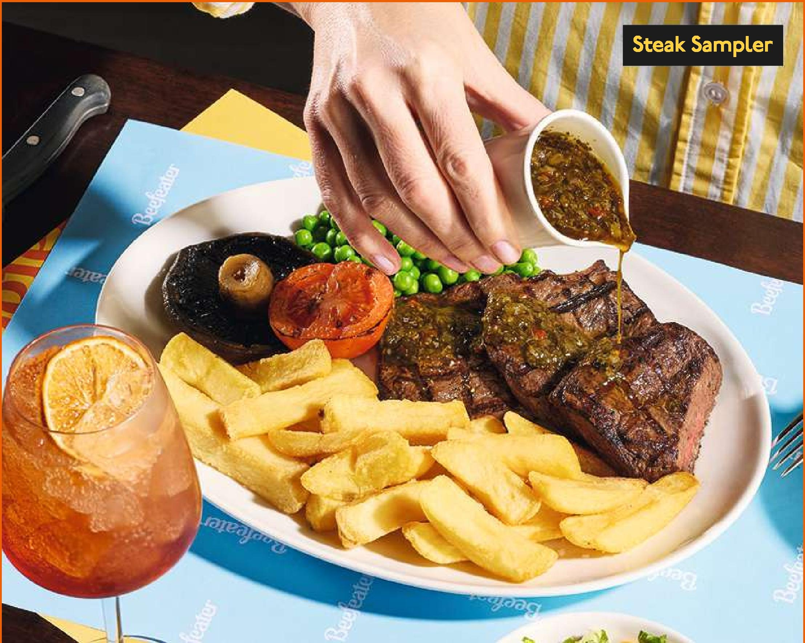

|  |  |
| --- | --- |
|  | **STEAKS** |
|  |

**Chopped House Salad (Ve)** (+41kcal)

g

**Four Chargrilied Garlic**

|  |  |
| --- | --- |
| **SIGNATURE STEAKS** | **STEAKS** |
|  |

**ALL our steaks come from British and Irish farms. Matured for 30 days, they are extra tender and full of flavour.**

Served with half a grilled tomato, grilled mushroom, garden peas, your choice of side and steak sauce.

|  |  |
| --- | --- |
| **1. CHOOSE YOUR CUT**  **8oz* Fillet 23.29**  **Skin-On Chips (Ve)** (+277kcal)  The most lean and tender of all steaks (440kcal)  **10oz* Ribeye 20.79**  The strong marbling makes this steak full  of flavour (615kcal)  **8oz* Sirloin 18.29**  A great all-rounder, for succulent texture  and taste (436kcal)  **8oz* Rump 15.79**  A matured, flavoursome taste (435kcal)  **Steak Sampler 26.29**  **A combination of our quality cuts:**    **4oz* fillet, 4oz\*** sirloin **and**  **4oz* rump** (610kcal)    **Add Truffle & +0.99**  **Porcini Butter (V)** (+70kcal) | **2. CHOOSE YOUR SIDE**  **Skin-on Chips (Ve)** (+277kcal)      **Triple-Cooked Chips (Ve)** (+395kcal)  **3. CHOOSE YOUR SAUCE**  **Diane Sauces** (+8lkcal)  **Chimichurri6 (Ve)** (+120kcal)  **Crab Hollandaise** (+78kcal)  **Peppercorn Sauce** (+39kcal)  **SURF YOUR TURF**  **Two Chargrilled Garlic +3.99**  **King Prawns"** (+I68kcal)  **Four Chargrilied Garlic +5.99**  **King Prawns"** (+366kcal)  **WANT EXTRA?**  **HAVE A LOOK ON OUR SIDES** |

**B a c o n e a t e r**

**Fried Egg (V) 0. 99**

(+108kcal)

**THISTM Isn’t Bacon (V) 0. 99**

(+58kcal)

**Violife Slice (V) 0. 99**

(+57kcal)

**Grilled Halloumi 16. 29**

**& Mushroom (V)**

With our smokehouse tomato sauce, grilled veg and burger sauce (906kcal)

**Plant Stack (V) 16. 29**

GARDEN GOURMET® Sensational burger with Violife slice, THISTM Isn't Bacon,

and burger sauce (915kcal) 



**All served in a brioche-style bun with**

**lettuce, tomatoes and red onion, with**

**skin-on chips and slaw.**

**BURGERS**

Our Signature ’74 burger recipe

is a mix of short rib, chunk, flank

and bone marrow to help give

that rich -tasting, meaty flavour.



**Baconeater 16.79**

**Our signature 4oz* beef burger, with our bacon relish, oak-smoked b Cheddar cheese, crispy onions and light mayo** (1,028kcal)

**Beefeater Double Stac 17. 29**

Two signature 4oz* beef burgers, with BBQ sauce§, Cheddar cheese and burger sauce (1,236kcal)

**Double-Crunch Chicken 17. 29**

Our crunchy tortilla coated chicken breast seasoned with our signature blend of spices, with BBQ sauce§, oak-smoked bacon and burger sauce (1,068kcal)

**Swap to grilled Chicken Breast** (841kcal)



**Signature 4oz* Beef Burge 2. 99**

(+223kcal)

**GARDEN GOURMET® Sensational2.99 Burger (Ve)** (+224kcal)

**Oak-Smoked Bacon 0. 99**

(+63kcal)

**Cheddar Cheese Slice (V) 0. 99**

(+83kcal)



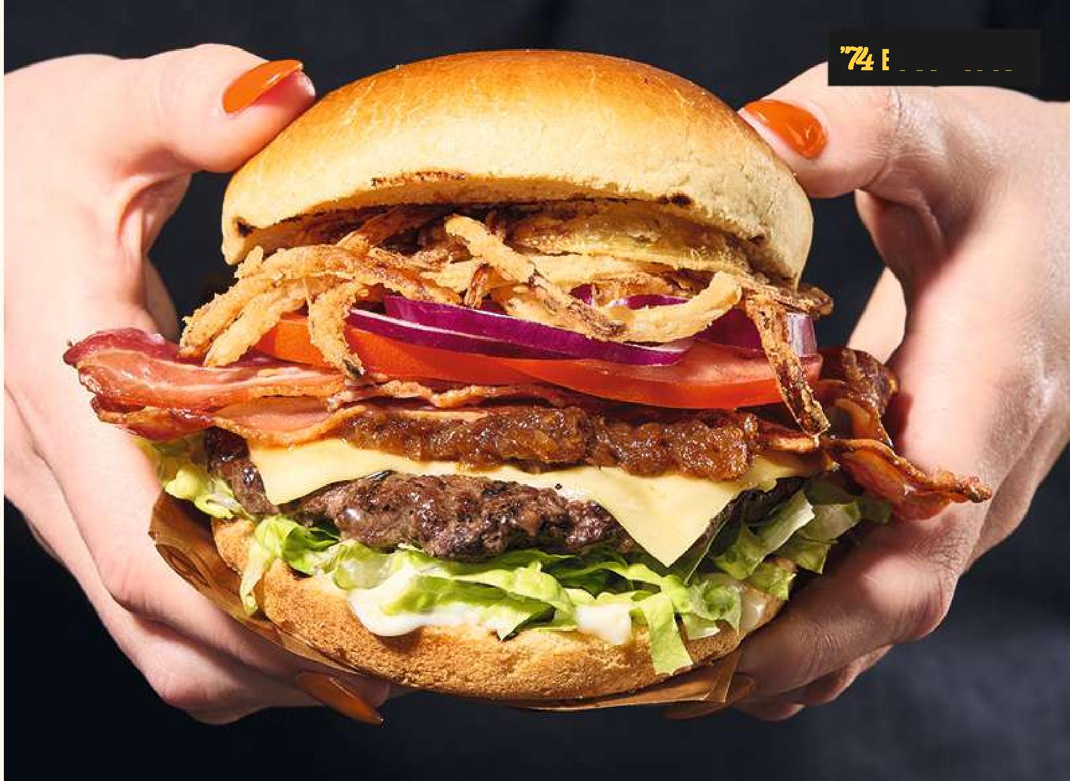

**Chicken Schnitzel 17.29**

**CHICKEN RIBS**  

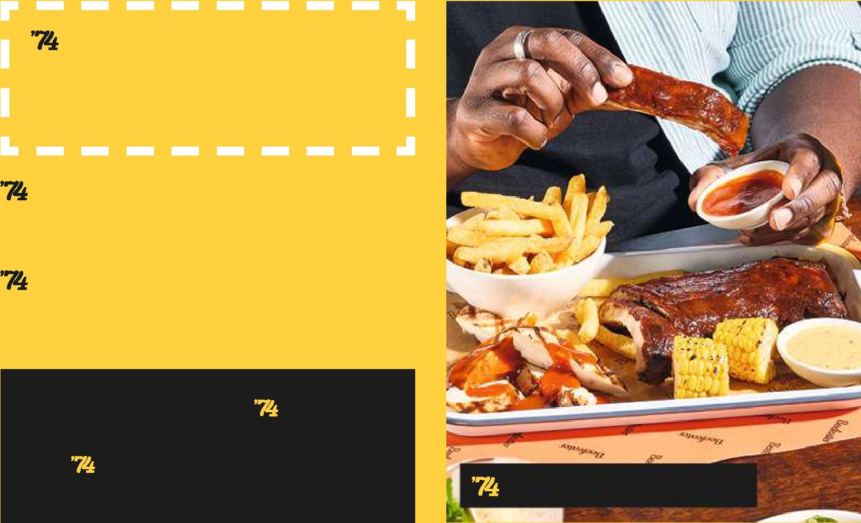

**Rack of Pork Ribs §21.49**

With corn and your choice of '74 sauce (1,025kcal without sauce)

**Chicken & Rib Combo§19.49**

With corn and your choice of '74 sauce (857kcal without sauce)

**Add half a rack of tender BBQ +6.99**

**Glazed Pork Ribs** (+339kcal)

**Add Double-Crunch +4.99**

**Chicken Wings** (+422kcal)

**Honey Sriracha Pork 23.49**

**Rib Stack§**

**With grilled pineapple salsa and slaw** (1,206kcal)

**Chicken & Rib Combo**

Topped with salsa verde , grated Parmesan and a fried egg. Served with skin-on chips and rocket (1,047kcal)

**Chargrilled Smothered 15.79**

**Chicken Melt**

Glazed in your choice of our '74 sauce topped with oak-smoked bacon and cheese. Served with skin-on chips, a salad garnish and slaw (685kcal, calories without sauce)

**Want to make it vegan? Just ask!**

With GARDEN GOURMET® Sensational TM Chicken Style Fillet, THIS TM Isn’t Bacon, Violife slice (Ve) (653kcal)

With triple-cooked chips, garden peas and a jug of gravy (1,067kcal)

**Beef & Ale Pie 14.79**

With triple-cooked chips, garden peas and a jug of gravy (1,067 kcal)

**Beef Lasagne 14.79**

With garlic flatbread and a chopped salad (634kcal)

**Butternut Squash, Spinach 14.79**

**& Ricotta Lasagne (V)**

With garlic flatbread and a chopped salad (677kcal)

**Beer-Battered Fish & Chips **§ 16.29**

With triple-cooked chips, tartare sauce, mushy peas (1,004kcal) or garden peas (966kcal)

|  |  |
| --- | --- |
| **’74 Seasoned Loaded Chips (V) 4.49**  With Cheddar cheese sauce and your choice  of our '74 sauce (380kcal without sauce)  **Triple-Cooked Chips (Ve) 3.49**  (395kcal)  **Skin-On Chips (Ve) 3.49**  (277kcal)  **Crushed Roasted Potatoes 3.49**  **(Ve)** (512kcal)  **Beer-Battered Onion Rings§ 4.49**  (436kcal)  **Grilled Flat Mushrooms 3.79**  **with Truffle & Porcini Butter (V)**  (189kcal) | **Grilled Veg with**  **Chimisurri (Ve) 3.79**  Grilled courgettes with asparagus, mixed  Peppers and red onions (194Kcal)  **’74 Seasoned Mini Corn**  **on the Cobs (Ve)** (81kcal) **3.49**  **Rocket, Parmezan**  **& Tomato Salad** (78kcal) **3.49**  **Greek Salad (Ve)** (182kcal) **3.49**  **Chopped House Salad (Ve)4.49**  (436kcal) |

**Baked New York-Style 6.99**

**DESSERTS**

**Banoffee Cheesecake (V)**

Served with vanilla ice cream (782kcal)

**Italian Lemon & Raspberry 6.49**



**Mango & Passionfruit 6.99**

**Sundae§ (V)** (436kcal)

**Millionaire's Triple-choc 6.49 Brownie Sundae (V)**

(801kcal)

**Biscoff® Sundae (V) 6.99**

(609kcal)

**Want to make it vegan? Just ask! (Ve)** (626kcal)

**Semifreddo (Ve)**

95677/BE/SS25/B3

**Black Forest Gateau § 6.49**

(605kcal)

**Apple & Blackberry 6.29**

**Crumble (V)**

Served with either custard (449kcal) or vanilla ice cream (419kcal)

**Want to make it vegan? Just ask! (Ve)** (440kcal)

**Sticky Toffee Pudding (V) 6.29**

Served with custard (624kcal) or vanilla ice cream (594kcal)

**Vanilla Ice Cream (V) 5.99**

With chocolate (298kcal), caramel (299kcal) or raspberry (286kcal) sauce

**Vegan option available (Ve)**

Choose from chocolate (359kcal) or raspberry

**Adults need around 2,000kcal a day**

Don’t worry, we know there are allergens in our food that we need to tell a specific allergy or would like more information about our dishes. Menu d please ask for more information. Ingredients can occasionally be substitu allergy information on the website at the time of yyo urri v "V” i= suitable for svegetarians, “Ve” = suitable for vegans and vegetarians. Our vegan dishes are made to a vegan recipe but we cannot guarantee that they are suitable for those with MILK or EGG allergies. *Approximate weight uncooked. **May contain small bones or shell. §May contain traces of alcohol. †May contain rings & tentacles. Fish, meat and poultry dishes may contain bones. The calories provided are based on the average serving size for the whole dish or drink as detailed on the menu, unless otherwise stated. We ensure that the calorie information provided is as accurate as possible and correct at time of printing, however some product variation may occur. Ingredients are occasionally substitued or changed which may affect the calorie information. GARDEN GOURMET® - is a registered trademark used in agreement with the trademark oner. Terms & conditions: Images are for illustrative purposes only and finished steak presentation (including grill lines) may vary. This menu is available for a limited time only and is subject to availability. We may occasionally sell out of some of the more popular dishes.If we do, we’ll do our very best to offer you the nearest alternative. Prices are inclusive of VAT. We hope we served you up a great experience today. If you choose to leave a gratuity to thank your server, we want you to know that this goes straight to the person serving you today, in full. If you have any comments or suggestions, our staff will be more than happy to receive them. Alternatively, you are welcome to write to us at: Whitbread Group PLC, PO Box 777, Dunstable, Beds. LU5 5XE. Telephone: 0333 234 1452 or visit [www.beefeater.co.uk/contact-us](http://www.beefeater.co.uk/contact-us). html

|  |  |  |  |
| --- | --- | --- | --- |
|  | Scan the QR code to see our NGCI menu |  | Seafood with this ma  comes from an MSC certifie sustainable fishe [www.msc.org](http://www.msc.org). MSC |
|  |
|  |  |

|  |  |
| --- | --- |
| We’ve teamed up with Penn charity box, to help sup GOSH Charity. Just press pay by card to d  Every penny you give goes to charity: 95% to Great Ormond Street Hospital Children’s Charity (registered charity no. 1160024) and 5% to Pennies (registered charity no. 1122489). |  |
|  |
|  |



**Mango & Passionfruit Sundae**

**Millionaire's Triple-Choc Brownie Sundae**